Insitut Superieur de l’Aeronautique et de l’Espace

ISAE SUPAERO

**Mini Project**

**Intercooled engine modeling and parametric sizing studies**

Aeroengines

April 17, 2017

Shubham AGARWAL

Vivek VIVEK

Elina Ishcander SÁNCHEZ ESTEVES

# Introduction

# Aircraft specifications and design assumptions

The given details about the aircraft are that it belongs to a short/medium range classification for which the Leap Engine was developed by Safran and General Electric:

Using the program of GasTurb, the goal is to, based on given parameters, obtain the best performance possible, using the analysis seen in class for this, along with what has been seen on the slides.

## Engine Design

Using a 3-shaft engine, an analysis without intercooler is the first step to be taken for comparisons. On this case, the flows are separated as follows:

* Bypass located just downstream of the fan
* LPT drives the fan
* IPT drives the booster
* HPT drives the HP Compressor
* The flows are divided into separate nozzles after LPT

A single type of engine was chosen for the experiment, being the model PW6000 of Pratt & Whitney whose characteristics are written in table 1.

|  |  |  |  |  |
| --- | --- | --- | --- | --- |
|  | Value |  |  |  |
| Take-off thrust | 23000 | Lbf | 102.3091 | kN |
| Maximum climb thrust | 6300 | Lbf | 28.0238 | kN |
| Maximum continuous thrust | 5600 | Lbf | 24.91004 | kN |
| Maximum cruise speed | 3500 | Lbf | 15.56878 | kN |
| BPR | 4-6 | - |  | - |
| Maximum fan diameter | 57 | in | 1.45 | m |

Table 1. Values of PW6000

Along with these requirements, a set of technological features are set into the program, where the LPC, IPC and the Recuperator’s designs are deactivated (this means that they will not be considered for the GasTurb results and simulation), this is made so that the focus can be on the compressors and their behaviors as the pressure increases at each iteration. Analysis will not be made on a blank file, rather using a base file called Demo_IRF.CIR where there are predetermined values which will be modified as the experimentation carries on. Along with these, a list of predetermined values is given, including instructions to set additional values that will be explained as the experiments carry on. The basic data that will be required in the program for the rest of the experiments and is shown on Image 1:

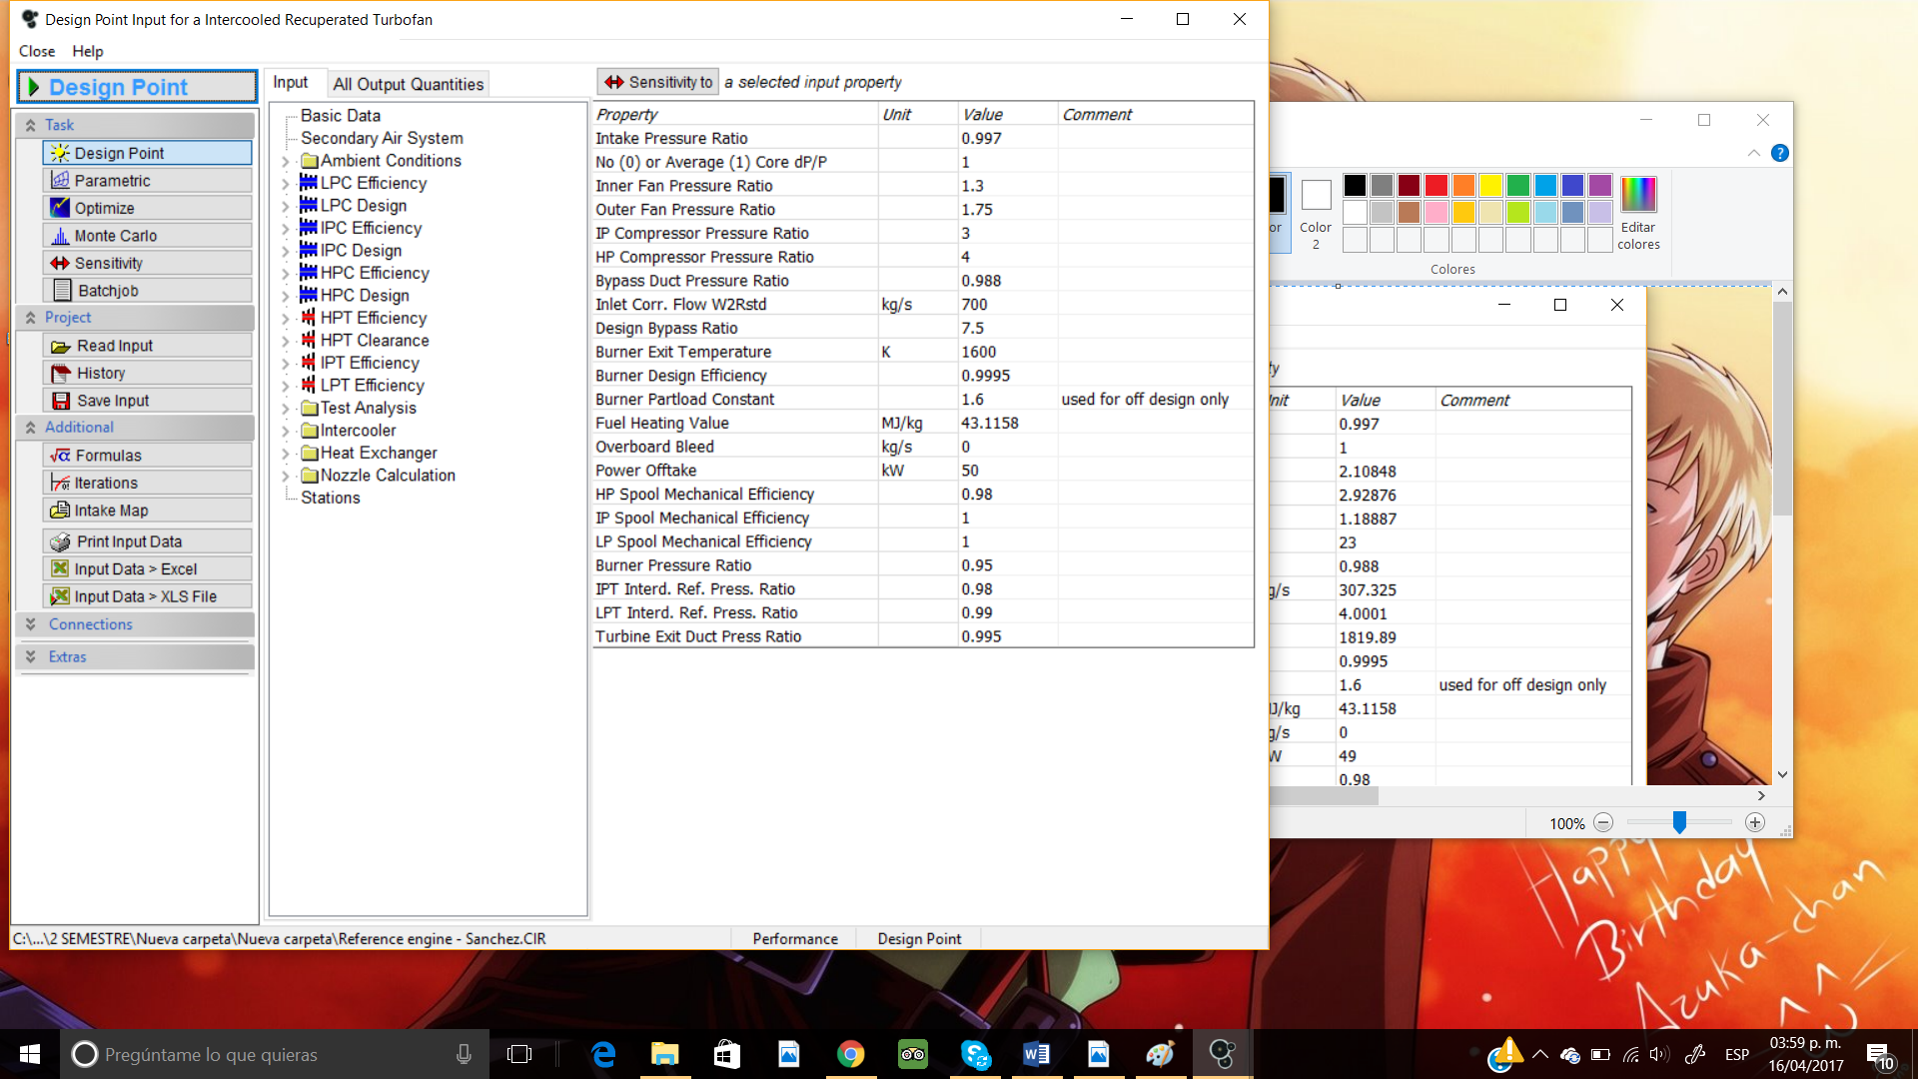

Image 1. Set of initial values

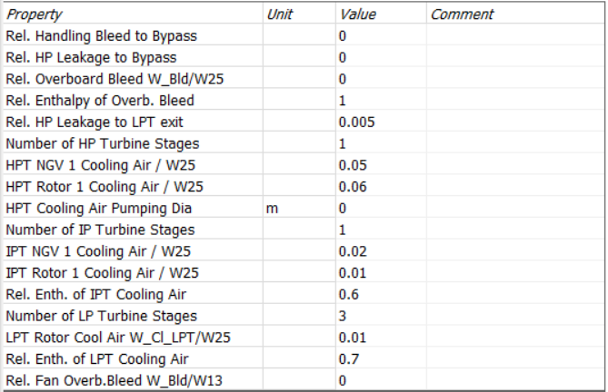

Image 2. Secondary Air system values

On this part of the experiment, the initial parametrization is done with the intercooler off: this stands for having the intercooler effectiveness in a value of zero, as Image 3 displays.

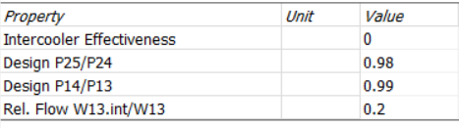

Image 3. Values of the intercooler display

After the values and parameters have been established, the first simulation is made; by clicking on the design point, it is expected for the iteration to converge but, what does this mean? In terms of GasTurb, it means that the engine simulation is working and the given values do allow a feasible working condition instead of creating generating unrealistic situations that will not be met by the turbine.

With the current values shown in Image 1, 2 and 3, the first iteration successfully converges:

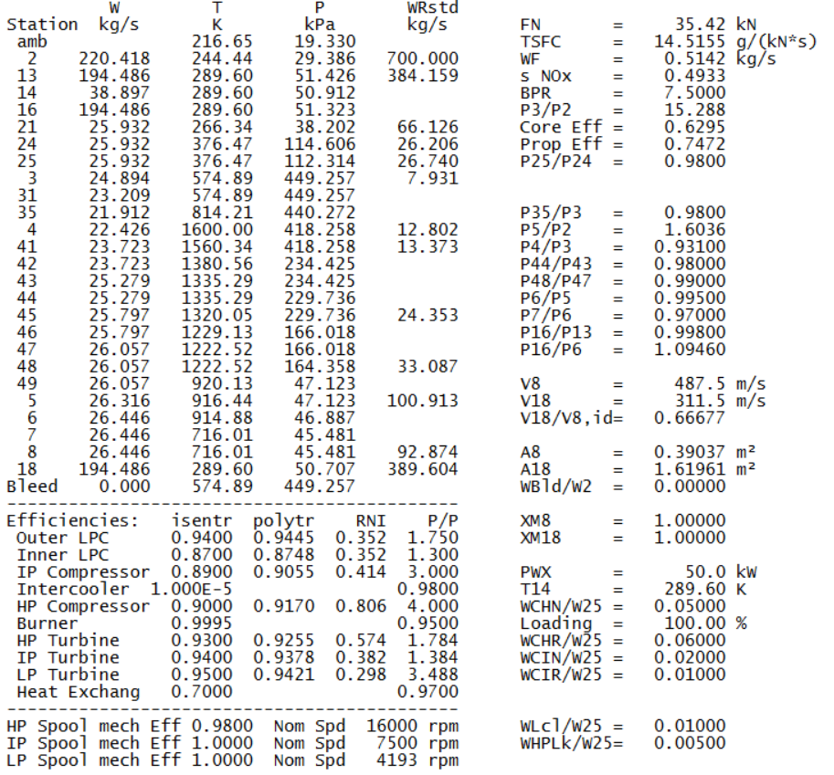

Figure 1. First Iteration of values

However, this system is far from perfect, as the conditions displayed do not meet with those specified on Table 1. To fix this issue, the engine’s values must be modified, along with generating a set of equations to set these values.

## Setting up the model

The Maximum Climb design point is considered; this means the value of the maximum climb thrust is the first value to be modified for the simulation along with several other values to fit this and the conditions of Table 1. For this, a set of formulas was defined to allow the program to determine the steps to iterate to reach the desired values:

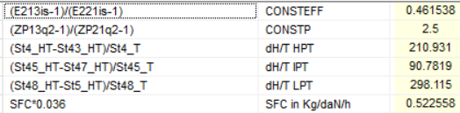

Image 4. Formulas

This set of equations acts as constraints of sorts to determine the values to be used into later processes: each equation has a specific function.

|  |  |
| --- | --- |
| CONSTEFF | The relationships between the fan hub performance and the fan tip performance |
| CONSTP |
| dH/T HTP | Thermodynamic loads of the different turbines |
| dH/T ITP |
| dH/T LTP |
| SFC in kg/daN/h | This is to transform the SFC into the units used for the formulations |

## Key engine designs comparison

These values are also accompanied by a set of iterations, made specifically for CONSTEFF and CONSTP to have two established values, shown in Image 5.

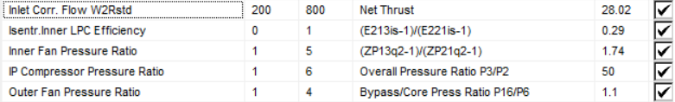

Image 5. Values of iterations

On this step, some of the previously defined formulas are set as the goals while the variables (on the left) are chosen from analysis given how they can affect the overall structure of the engine. The explanation will be given below.

Image 5 illustrates that, to obtain specific results for different sets of equations, some of the values must be related to other variables which are chosen for the conditions these present, such as the IPC pressure ratio as it is directly linked to the P3/P2, as it is a stage where this occurs. The Outer Fan Pressure Ratio is related to the Bypass Pressure Ratio more in the terms of being the section where the bypass flow comes into, therefore the diameter and pressure differences will affect these values directly; a similar case occurs with the Inner Fan Pressure Ratio and the CONSTP formula, having these sets of values to be relevant due to the placing of the stages and how the size of the fan, mass flow going through and the accompanying pressure distribution may increase or decrease through these. For the Net Thrust, the relationship between this and the Inlet Corrected Flow relies on the fact that this is derived from the relation between the flow that comes from the inlet and the size it must have to allow the Net Thrust that is expected

These iterations do present modifications to the original values that were obtained, therefore the implementation of each one had to be done carefully since they could potentially lead to the divergence of the system. The values between the steps to be modified and the targets represent the number of assumed iterations that will take GasTurb to reach the desired value; some of these have been assumed from looking at the original values and determined by estimations while the “goal numbers have been chosen between ranges of values that will be mentioned in the optimization part, yet these are subject to change as well, given how these must generate adequate conditions for the set of data that is expected to be reached.

Another modification that should be made into the equations are the setting of parameters such as:

|  |  |  |
| --- | --- | --- |
| OPR | ~ | 45 – 60 |
| P3Q25 | = | 23 |
| T4 | < | 1890 K |
| T49 | < | 1200 K |
| dH/T HPT | < | 400 J/kg/K |
| dH/T HPT | < | 150 J/kg/K |
| dH/T HPT | < | 450 J/kg/K |
| P16Q6 | ~ | 0.9 – 1.3 |

Some of these values will be modified in further experiments to maintain the and achieve the desired performance values and, while some might not reach the limit, some must be lowered drastically so that P3Q25 will retain the specified value: however, this value has been somewhat unfitting given how it forces the rest of the stages to reach higher values. It has been states that the engine is an old model for study, therefore it may justify the reason why a lower number for this specific value would be more fitting yet, to continue with the experimentation and obtain a reasonable line of results, this shall not be changed.

Figures 2 and 3 show the results the formulas and iterations have on the resulting simulation: reducing successfully the inlet tip diameter to a value less than the limit marked on a previous table along with reducing the Net Thrust to that of the climbing condition yet this has also brought drastic changes to other values such as the mass flow through the stations, decreasing greatly on station 2 in comparison to the first set of data obtained in Figure 1

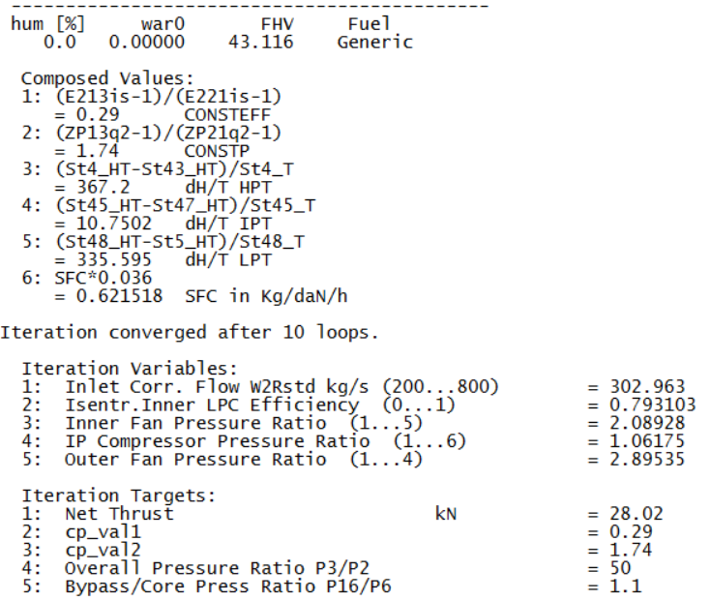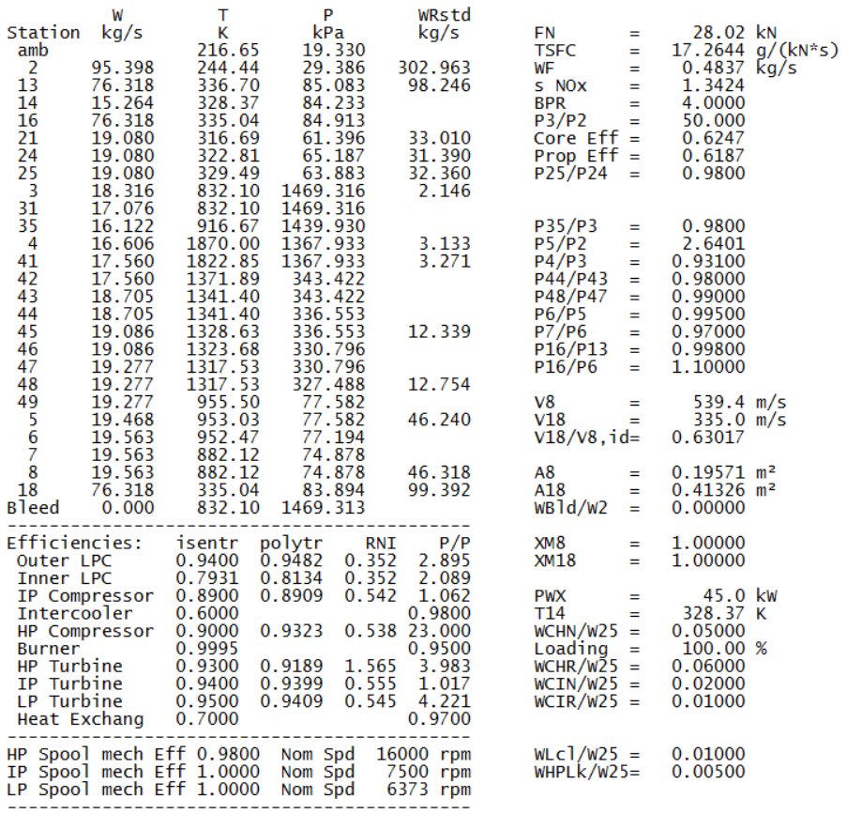

Figure 2. Set of values after several iterations

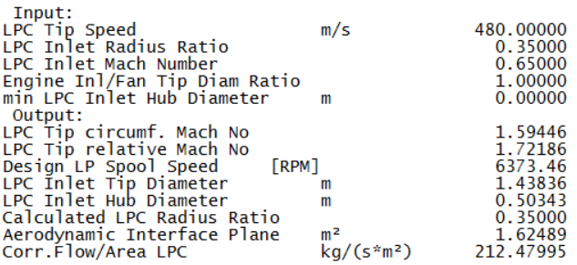

Figure 3. Fan diameter after several iterations

Efficiencies, on the other hand, do vary as some of them were modified directly or because of the iterations done to reach the desired values.

# Sizing Parametric Studies

On this part, the goal is to assess the impact of some of the performances by modifying the parameters, eliminating the efficiency for the first part, then using the efficiency for the same experiment.

## Optimization

Using the optimization tool of GasTurb, the goal of this point is to modify the values of the BPR, OPR, Burner Exit Temperature T4 and P16Q6 to their optimal level that must be between the values described below, remembering to maintain the constraints of fan diameter, HP and LP turbine loads

|  |  |  |
| --- | --- | --- |
| OPR | ~ | 45 – 60 |
| P3Q25 | = | 23 |
| T4 | < | 1890 K |
| T49 | < | 1200 K |
| dH/T HPT | < | 400 J/kg/K |
| dH/T HPT | < | 150 J/kg/K |
| dH/T HPT | < | 450 J/kg/K |
| P16Q6 | ~ | 0.9 – 1.3 |

Using Endless Random as an option for obtaining the optimized process gives the cycle an infinite amount of combinations where the values can reach the optimal performance through different data.

### Without intercooler

For this part, the Intercooler effectiveness has been set to a value of zero and the configuration of variables and constraints obtaining the following results on the optimization:

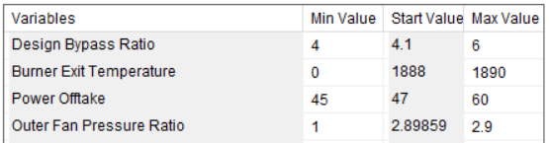

Table 2. Variables for optimization

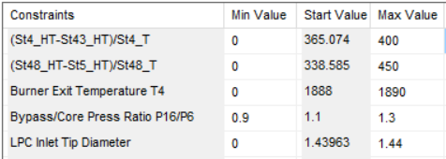

Table 3. Constraints for optimization

For the variables, to affect the Bypass Pressure Ratio P16Q6, the adjustment of the Outer Fan Pressure Ratio was required, a setting that was previously used for the iterations as this is the stage that affects the afore mentioned directly.

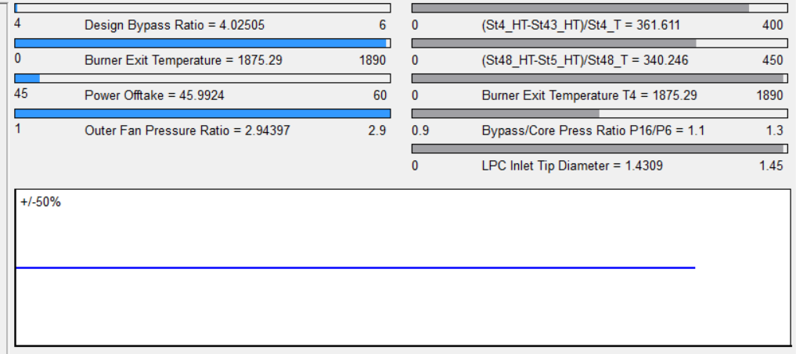

Figure 4. Endless Random strategy

Given how some of the values were already high and close to their respective limits, the variation of combinations was drastically reduced; to fix this would mean that there would be several adjustments to be made to various factors so the Inlet Tip Diameter (to take for example), could be less than 1.4399 meters before the optimization, this in turn would give a lesser Burner Exit Temperature along with a reduction of the Outer Fan Pressure ratio.

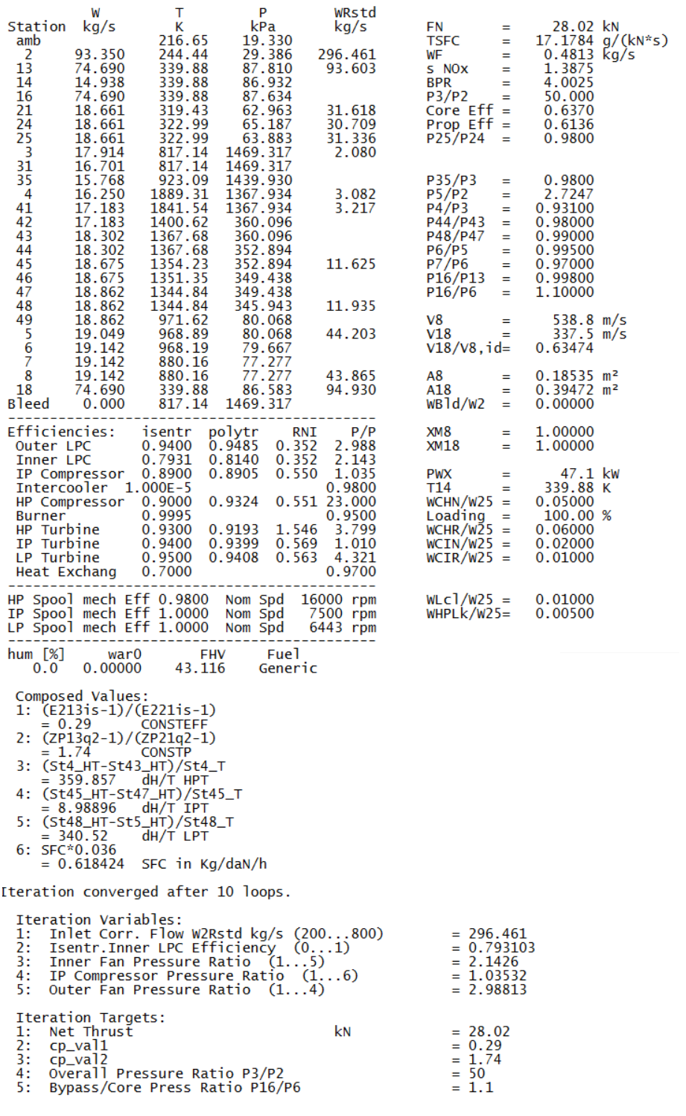

Figure 5. Optimized variables without Intercooler

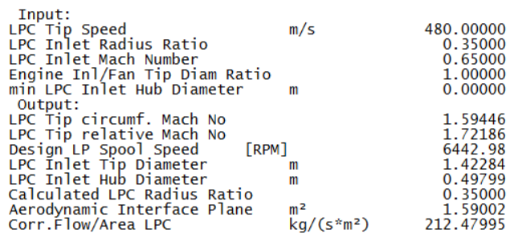

Figure 6. Fan diameter after optimization

Figure 5 shows the values obtained with this strategy of the Endless random simulation, it is worth to notice how values like the BPR had to increase to meet up with the best optimal performance, reducing temperatures drastically at T4 and T49 to do so: Figure 6 denotes that this has led to be at the maximum value allowed for the LPC Inlet Tip Diameter.

A Systematic research was performed, obtaining little variation in terms of the constraints yet the fan diameter was lower than the limit.

### Intercooler

With the Intercooler in a value of 0.65, the initial values had to be modified slightly so that the constraints would still be met (the added value of the intercooler increased the fan diameter to a higher number than the limit, therefore actions were taken to counteract this). Modify the value of T4 was one of them, reducing it slightly below the initial number to meet with this constraint.

On this case, whereas Figure 6 shows that the endless random process without intercooler didn’t reach the maximum value of the fan diameter, the same cannot be said about the Figure 7 where this was the case, showing that the tendency to reach the limit has not only affected the fan diameter, but also has created a general increase of flow and, on a lesser degree, temperature through the different stages: this is more visible on the IP and HP turbine loads.

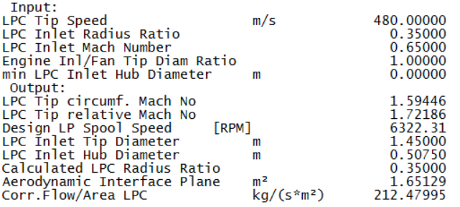

Figure 7. Intercooler results

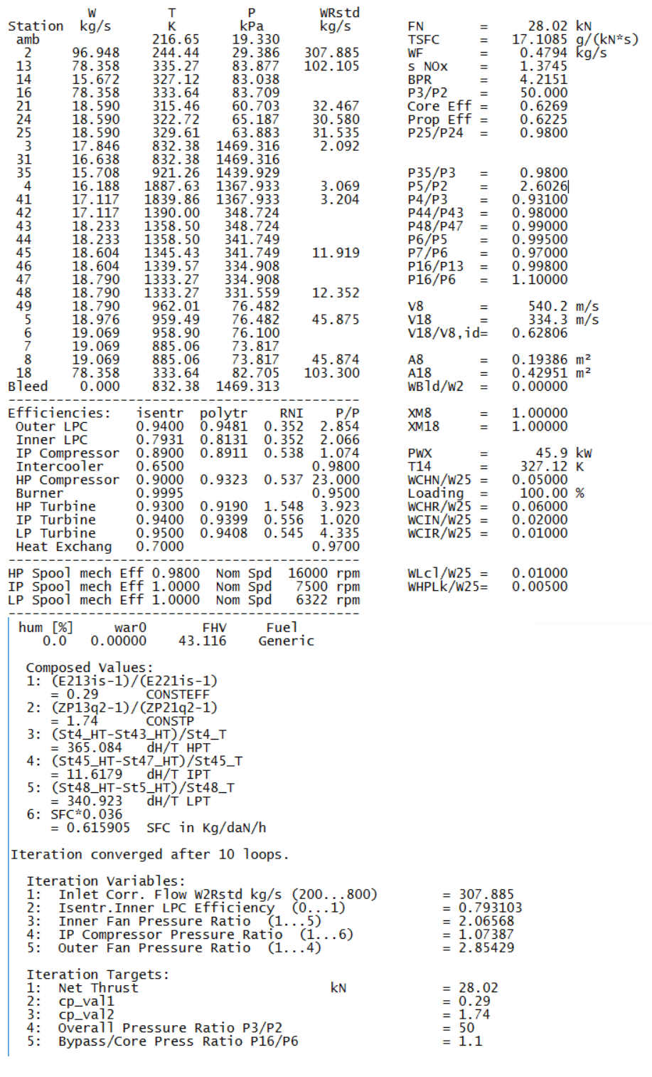

Figure 8. Performance with Intercooler

# Intercooler

On this stage, using the optimized file without intercooler, another set of parametric studies ensues, only to be later modified again by the introduction of the intercooler effectiveness of 0.65 along with other values:

* Hot flow pressure losses: PRh = 0.98
* Cold flow pressure losses: PRc = 0.99
* Heat exchanger efficiency Eff = 0.65
* Cold flow into intercooler = 15% of W13

### Techonological features

### Parametric study

Using the previous parameters again as variables for the graphs and analysis, a new value is added, the cold flow into the intercooler, ranging from 5% to 95% for parametric studies and, to compare evolutions, a corrected core size is generated as a new formula, Core size W25R3=W25*sqrt(T3/Tstd)/(P3/Pstd), where Tstd is 288 K and Pstd has a value of 101.3 kPa; this along with the SFC and the Inner Fan Pressure Ratio, will be b¿plotted to study how the variables evolve and what does this imply for the engine.

### Optimization

### Technology Influences

# Conclusion